WILMINGTON PARISH COUNCIL

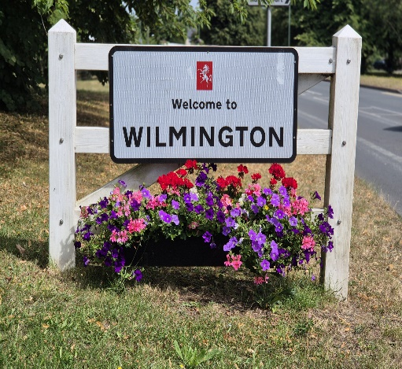

Agenda for the Meeting to be held on Wednesday 3rd June 2026
at Oakfield Park Pavilion, Wilmington commencing at 7.00pm
AGENDA
Prior to the Meeting the Chairman to draw attention to the protocol regarding the audio and visual recording of the Meeting or of any part thereof

- Apologies for Absence/Non-Attendance
None at the date of distribution
- Declarations of Disclosable Pecuniary or Prejudicial Interest

To receive any Declarations of Disclosable Pecuniary or Prejudicial Interest.

- Public Participation
To note or respond to any concerns raised or questions asked by residents in writing or in person prior to or at the Meeting

RECOMMENDATION – That any matter be noted; accepted as an ‘Urgent Item’ for discussion at the Meeting or deferred to a subsequent Meeting of the Council

- Kent County Council and Dartford Borough Council Reports

To receive verbal reports from the Parish Representatives on Kent County Council and Dartford Borough Council

RECOMMENDATION – That the verbal reports be noted

- Minutes of the Previous Meetings
To approve and adopt the Minutes of the Meeting held on 6th May 2026
RECOMMENDATION – That the Minutes be approved and adopted as true records

- Urgent Items

The Chairman to announce that the inclusion in the Agenda of the ‘Urgent Items’ as tabled had been agreed

- Finance

- Financial Statements

Having been circulated to Members in advance of the Meeting, to approve the Financial Statements for the month ended 31st May 2026

RECOMMENDATION – That the Statements be approved

- Annual Governance Accountability Return (AGAR3)
To note that the AGAR3 and supporting documents had been submitted to the External Auditor and the Notice of Public Rights published
RECOMMENDATION – That the matter be noted

- Kent County Council Refund

To note a refund of £70 from Kent County Council being the overcharge for the recently Load Testing of the streetlight columns used for the hanging baskets
RECOMMENDATION – That the matter be noted

- Matters Arising from Previous Meetings of the Parish Council (Not covered Elsewhere in the Main Agenda)
- Wilmington in Bloom – Horticultural Display Competition (‘the Competition’)

Note – Item deferred from May Meeting of the Council

- Having been circulated to Members in advance of the Meeting, to approve and adopt the Competition Policy and

- On the assumption that the Policy is adopted to –

- agree that the Competition be held in 2026
- appoint the Lead Member for the Environment
Cont’d………………

- appoint the Judges for the 2026 Competition and
- determine the value of the vouchers to be awarded

- To note that the lists of eligible addresses for each of the four Parish Wards will be given to the appointed Judges

RECOMMENDATION – That the Policy be adopted and other matters agreed or noted as appropriate

- Wilmington Fair 2026

- Having been circulated to Members in advance of the Meeting, to note receipt of the Minutes of the Meeting of the Fair Committee held on 12th June 2026
- To note that the fee of £410.00 for the required First Aid cover has been paid and that a payment of £260.00 made for the hire of the Inflatables

RECOMMENDATION – That the matters and decisions made be noted

- Items for Discussion

- Wilmington Parish Council Vice Chairman 2026/27

To –

- note that Councillor D Mann had self-nominated as Vice-Chairman for the year 2026/27
- receive any further nominations
- either agree that Councillor D Mann be appointed as Vice-Chairman or, in the event that other nominations/self-nominations made arrange for a ballot to be held

RECOMMENDATION – That either Councillor D Mann be elected as Vice-Chairman or that a ballot be held

- Chestnut Grove

- To note that -

- the installation of the new equipment and the improvements to the existing Play Area at Chestnut Grove had been completed on 15th May 2026
- all work had been subject to an Inspection Report with no findings of concern.
- Dartford Borough Council had advised that the cost of the Multiplay, excluding the installation and associated groundwork, was £64,986 and that the Council’s insurer has been advised and
- agreement has been reached with Dartford Borough Council for the reseeding of the aborted installation site to be undertaken by the Parish Groundsman with seeds supplied by the Borough Council

Cont’d ………..

- to receive a report from the Clerk on the question of fencing the MultiPlay area

RECOMMENDATION – That the matters be noted and the Clerk to act in any accordance with any decision(s) made

- Devolution – Consultation on Local Government Elections

To ratify the comments submitted to Dartford Borough for Parish Council Elections in response to the Consultation
RECOMMENDATION – That the submitted comments be ratified

- Planning Applications for Consideration and to Note Any Agreed Comments or Observations submitted to the Planning Authority prior to the Meeting

- DA/26/00534/FUL – 21 Birchwood Road, Wilmington

Demolition of garage. Changes to existing rear extension including: side extension, changing pitched flat roof to pitched roof, addition of two skylights. Addition of front open porch

- DA/26/00542/FUL – 51 Birchwood Road, Wilmington

Demolition of the conservatory and erection of a single storey rear extension with the addition of a new door and window to the side elevation of the existing house

- DA/26/005699/TRCON – Homestead, Church Hill, Wilmington

Notification to re-pollard 1 no. Sycamore tree (T1); Reduce height of Conifer tree by 4 metres (from approx. 14-15 metres to approx..10-11 metres) within Church Hill Conservation Area

RECOMMENDATION – That the Clerk submits any agreed comments or observation to the Planning Authority
- Chair’s Updates

To receive any updates from the Chair.
RECOMMENDATION – That any updates be note

- Parish Ward Matters Raised by Members

To receive any Ward Matters raised by Members
RECOMMENDATION – That any matters raised be noted and, where a decision is required, for the Chairman to agree that it be accepted as an ‘Urgent Item’ or that it be included on the Agenda for the October Meeting of the Council

- Items to Note or Endorse the Actions Taken

- Dartford Borough Council Planning Decisions

None

- Dartford Borough Council Planning Appeal Lodged
- DA/23/01157/FUL – 22 The Close, Wilmington

- Dartford Borough Council Planning Appeal Decisions

None

- Kent County Council Planning Applications

None

- Kent County Council Planning Decisions

None

- Other Items to Note or Actions Taken Endorsed

To note or endorse other items received or actions taken as appropriate being –

- having been circulated to Members in advance of the Meeting, to note receipt of the Kent Community Wardens’ Annual Report for 2025/26
- to note that an inspection of the facilities at Oakfield Park has been scheduled for 9th June 2026 to assist in the preparation of Dartford & Gravesham Borough Councils’ Playing Pitch and Sports Facility Strategy
- to note the acceptance of the quote to remove the felled tree from the wooded area at Parsons Lane with the work subsequently completed at a cost of £300.00
- Having been circulated to Members, with the response approved by the Chairman, to note an exchange with a resident regarding Village Centre CCTV coverage noting that this will be further considered at the November Meeting of the Council

Following publications are available for Members –

- SLCC – The Clerk (May 2026)

