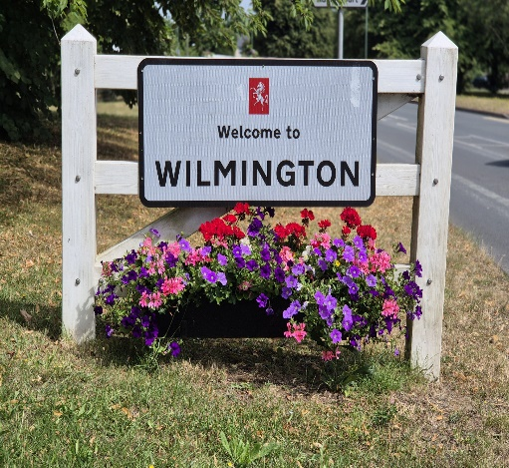

WILMINGTON PARISH COUNCIL

Agenda for the Meeting to be held on Wednesday 4th March 2026
at Oakfield Park Pavilion, Wilmington commencing at 7.00pm
AGENDA
Prior to the Meeting the Chairman to draw attention to the protocol regarding the audio and visual recording of the Meeting or of any part thereof

- Apologies for Absence/Non-Attendance
Councillor S Narwan; J Denne and S Brown
- Declarations of Disclosable Pecuniary or Prejudicial Interest
To receive any Declarations of Disclosable Pecuniary or Prejudicial Interest.

- Public Participation
To note that comments received in connection with the installation of a ‘Multi-Play’ at Chestnut Grove had been sent to Members in advance of the Meeting and would be covered at Agenda Item 8(b)

- Kent County Council and Dartford Borough Council Reports

To receive verbal reports from the Parish Representatives on Kent County Council and Dartford Borough Council

RECOMMENDATION – That the verbal reports be noted

- Minutes of the Previous Meetings
To approve and adopt the Minutes of the Meeting held on 4th February 2026
RECOMMENDATION – That the Minutes be approved and adopted as true records

- Urgent Items

The Chairman to announce that the inclusion in the Agenda of the ‘Urgent Items’ as tabled had been agreed

- Finance

- Financial Statements

Having been circulated to Members in advance of the Meeting, to approve the Financial Statements for the month ended 28th February 2026

RECOMMENDATION – That the Statements be approved

- 2025/26 Budget Forecast

Having been circulated to Members in advance of the Meeting, to note the Budget Forecast for the year ending 31st March 2026

RECOMMENDATION – That the Budget Forecast be noted

- London Green Belt Council

To consider the renewal of the Council’s membership of the London Green Belt Council at a cost of £25.00

RECOMMNENDATION – That the Clerk acts in accordance with the decision made

- Matters Arising from Previous Meetings of the Parish Council (Not covered Elsewhere in the Main Agenda)
- The Rosemary Centre - Update

To note any report from the Developer

RECOMMENDATION – That the position be noted

- Chestnut Grove Multi-Play Equipment

Having circulated a Briefing Paper to Members containing illustrations of the Multi-Play; original and suggested sites; comments received by the Parish Council and posted on the Joydens Wood Community Facebook page in respect of the original site; a copy of the Chairman’s letter posted on social media on 16th February 2026 and comments received by the Parish Council on the suggested revised site, to further consider the installation of the Multi-Play

RECOMMENDATION – That the Clerk acts in accordance with the decision made

- 2026 Big Spring Clean
To receive a report on the arrangements made

RECOMMENDATION – That the arrangements be noted

- Items for Discussion

- Pavilion Keyholder

To appoint a Member as the contact for the Pavilion in the event of the alarm being triggered with no employee on site

RECOMMENDATION – That a Member be appointed and that the Clerk notifies the Alarm Company

- Road Safety & Active Travel Group (RSATG) Seminar

Having been circulated to Members in advance of the Meeting, to respond to an invitation to a Seminar hosted by the RSATG noting that Councillor J Denne had expressed an interest in attending

RECOMMENDATION – That the Clerk notifies the Organiser of Councillor J Denne’s and any other Member’s attendance

- Planning Applications for Consideration and to Note Any Agreed Comments or Observations submitted to the Planning Authority prior to the Meeting

    - DA/26/ 00135/FUL – 212 Birchwood Road, Wilmington Erection of an outbuilding for office, storage and gym

    - DA/25/01156/FUL – 194 Birchwood Road, Wilmington Erection of single storey residential annexe in rear garden (Revision being change in applicant names on the application form)

    - DA/26/00142/FUL – 47 Warren Road, Wilmington Erection of a single storey rear extension

    - DA/26/00164/FUL – 5 Alfan Lane, Wilmington Erection of a front porch to front and pitched roof with roof lights over existing rear extension with insertion of roof lights

    - DA/26/00147/VCON – Former Lynch Plant Site and Ambulance Station, Hawley Road, Dartford To allow an interim Open Storage use on Phase 2B with associated works. (Permission Ref 25/00760/VCON was for Demolition of existing buildings and construction of buildings to provide flexible employment floorspace (Use Classes E(g)/B2/B8, with ancillary office accommodation within Use Class E (g)), together with the creation of a new vehicular access via Butterly Avenue, improvements to the existing vehicular access from Hawley Road, provision of car and cycle parking and service yards, drainage works, landscaping, installation of an acoustic fence and other associated works (variation of conditions pursuant to planning permission DA/20/01202/FUL - condition 2 (approved plans - to include elevational changes, changes to external parking arrangements and landscaping layout, increase in mezzanine floorspace, and changes to approved Energy Statement), 9 (Flood Risk & Drainage details - to allow for the drainage scheme to be implemented in phases) 15 (Landscaping - new external amenity areas), 17 (Travel Plan - to allow submission prior to occupation of each unit), 22 (BREEAM - to allow submission within 6 months of occupation) and 30 (Mezzanine Floors - to restrict additional mezzanine floors only))

    - DA/26/00181/FUL – 1 The Close, Wilmington Erection of a single storey front extension

- Chair’s Updates

To receive any updates from the Chair.
RECOMMENDATION – That any updates be note

- Parish Ward Matters Raised by Members

To receive any Ward Matters raised by Members
RECOMMENDATION – That any matters raised be noted and, where a decision is required, for the Chairman to agree that it be accepted as an ‘Urgent Item’ or that it be included on the Agenda for the October Meeting of the Council

- Items to Note or Endorse the Actions Taken

- Dartford Borough Council Planning Decisions

To note decisions made by the Borough Council being –

- DA/25/01295/FUL – Orchard House, 11 Barn End Drive, Wilmington Permission Granted
- DA/25/01415/FUL – 61 Birchwood Road, Wilmington Permission Granted
- DA/25/01453/FUL – 81 Birchwood Road, Wilmington Permission Granted
- DA/23/01157/FUL – 22 the Close, Wilmington Permission Refused
- DA/26/00008/TPO – 38 Squires Way, Wilmington Consent Granted

- Dartford Borough Council Planning Appeal Lodged
- DA/25/01349/FUL - 4 Dene Close, Wilmington

- Dartford Borough Council Planning Appeal Decisions

None

- Kent County Council Planning Applications

None

- Kent County Council Planning Decisions

None

- Other Items to Note or Actions Taken Endorsed

To note or endorse other items received or actions taken as appropriate being –

- having been circulated in advance of the Meeting to Councillor M Peters as the Parish Representative, to note receipt of notice of the London Greeb Belt Council’s AGM and Agenda to be held remotely on 2nd March 2026
- to note that, in certain circumstances, Dartford Borough Council Community Unit Officers are now able to seize untaxed vehicles

Following publications are available for Members
None

